[](https://www.myperfectresume.com/membership/RegisterGuestUser.aspx?wizard=true&productid=17&utm_source=hloom-com&utm_medium=referral&utm_campaign=word-template)

**Buy Now**

RAFFLE

**39” x 27” picture of Lone Pine Peak**

**$5.00 / Ticket or $20.00 / 6 Tickets**

**Support our Community!**

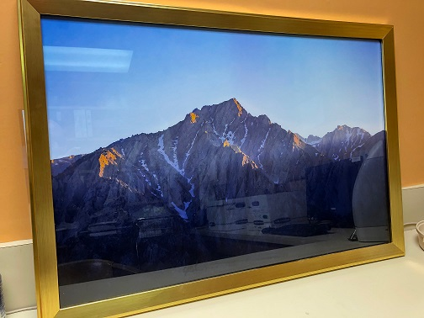

**See Linda in the Radiology Department to purchase your tickets.**

Drawing will be held during Our Inaugural Lone Pine Car Show. The address is: 501 E. Locust Street on May 11, 2019. All of the proceeds will go in the ‘general fund’ of the Southern Inyo Hospital Salvation. Check out our website!

http://www.sihsalvation.org